PROJECT DOCUMENTATION

RHYTHMIC TUNES : YOUR MELODIC COMPANION

# Introduction

**Project Title**: Rhythmic tunes: your melodic companion

**Team ID:** NM2025TMID37016

**Team Leader:**

**Name:** R. Poorvaja **& Email id:** poorvaja2006@gmail.com

**Team Members**

**Name**: Poojasri sureshbabu **& Email id:** poojasri.sbabu@gmail.com

**Name**: Poornitha R**& Email id**: poornithapoornitha507@gmail.com

**Name:** Pooja S **& Email id:** poojadee23@gmail.com

# Project Overview

**Purpose:** The purpose of Rythmic Tunes is to create a user-friendly music platform where users can easily explore, play, and enjoy different genres of music.

**Features:**

* Responsive design
* Music player interface
* Search Option
* Playlist Creation
* Attractive UI/UX

# 3. Architecture

* **Component structure:**

The project uses a modular, component-driven approach, built with react for better scalability and maintainability

* **State Management:**

Global state is handled through redux,while local state is managed using react hooks for improved data flow.

* **Routing**

React Router ensures smooth and uninterrupted navigation between different pages of the application.

# Setup Instructions

* **Prerequisites:**

- Node.js must be installed

- npm or yam package manager should be available

**Installation steps:**

Run npm install in the root project directory to install all dependencies.

Navigate to the server folder using cd…/server-side dependencies.

# 5. Folder Structure

rhythmic-tunes/

│

├── client/ # Frontend code

│ └── src/

│ ├── ui/ # Reusable UI components

│ ├── views/ # Complete pages/screens

│ └── resources/ # Stylesheets, images, and media files

│

├── server/ # Backend code

│ └── src/

│ ├── api/ # API route handlers

│ ├── schemas/ # Database models/schemas

│ └── services/ # Business logic and controllers

│

├── build/ # Production build files

├── documentation/ # Project notes, API docs, and setup guides

└── tests/ # Unit and integration tests

# 6. Running the Application

Run ‘npm start’ to launch the development server

**Access:** Visit <https://github.com/poojasrisbabu-rgb/Music.git>

# 7. API Documentation

* **User:** :
* – /api/user/register
* – /api/user/login

• **Tracks**

– /api/tracks

– /api/tracks/:id

• **Playlists**

– /api/playlists/create

– /api/playlists/:id

• **Favorites**

– /api/playlists/create

– /api/playlists/:userId

# 8. Authentication

• Secure login using JWT tokens

• Middleware ensures protection for restricted routes

# 9. User Interface

• Homepage design

• Dashboard for freelancers

• Admin control panel

• Project information page

**10**. **Testing**

• Manual checks at every development stage

• Tools used: Postman, chrome developer tools

# 11. Screenshots or Demo

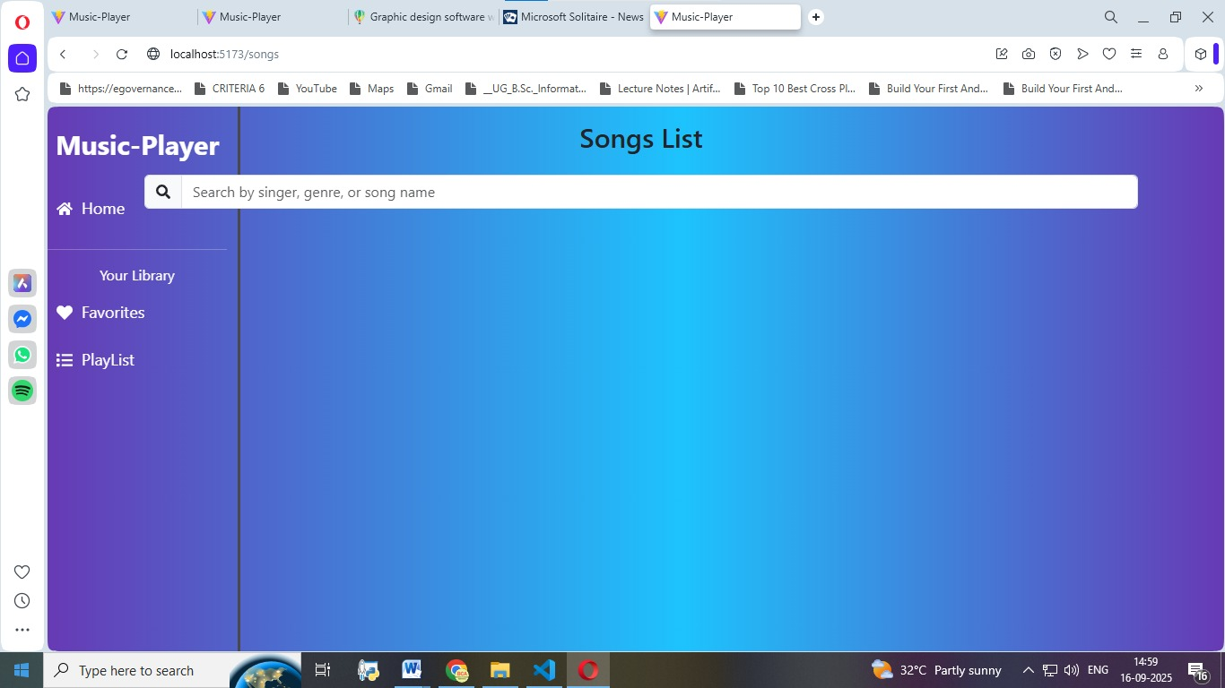

# 12. Known issues

* Limited functionality when used offline
* Occasional syncing problems with playlists

# 13. Future enhancements

* Smart, AI-driven playlist suggestions
* Compatibility across multiple platforms
* Better offline usability and features

# Conclusion

Rhythmic Tunes is created to be a flexible and easy-to-use music companion. With the planned updates, it strives to deliver a more immersive and customized music experience for users.